Justin Dietrich

Ryan Scott

9/18/2022

CST - 310

Prof Citro

**Project 2: Your Surrounding World**

We will follow a set of steps for developing a 3D representation of a scene from our daily lives as part of this and the following projects. This scene will demonstrate the type of details which need to be recreated in computer graphics. We will see subtle details that we may not notice when viewing the scene, but that are important in creating a realistic scene.

Using C++ and OpenGL, a graphics API, we can draw a scene using points, vectors, colors, and shapes. By cleverly using these tools, we can make a realistic-looking representation of a real-world scene.

One of the three environments will be chosen by Prof. Citro to represent the subject in this project.

I (Justin) took these next four pictures with my phone.

My room desk:

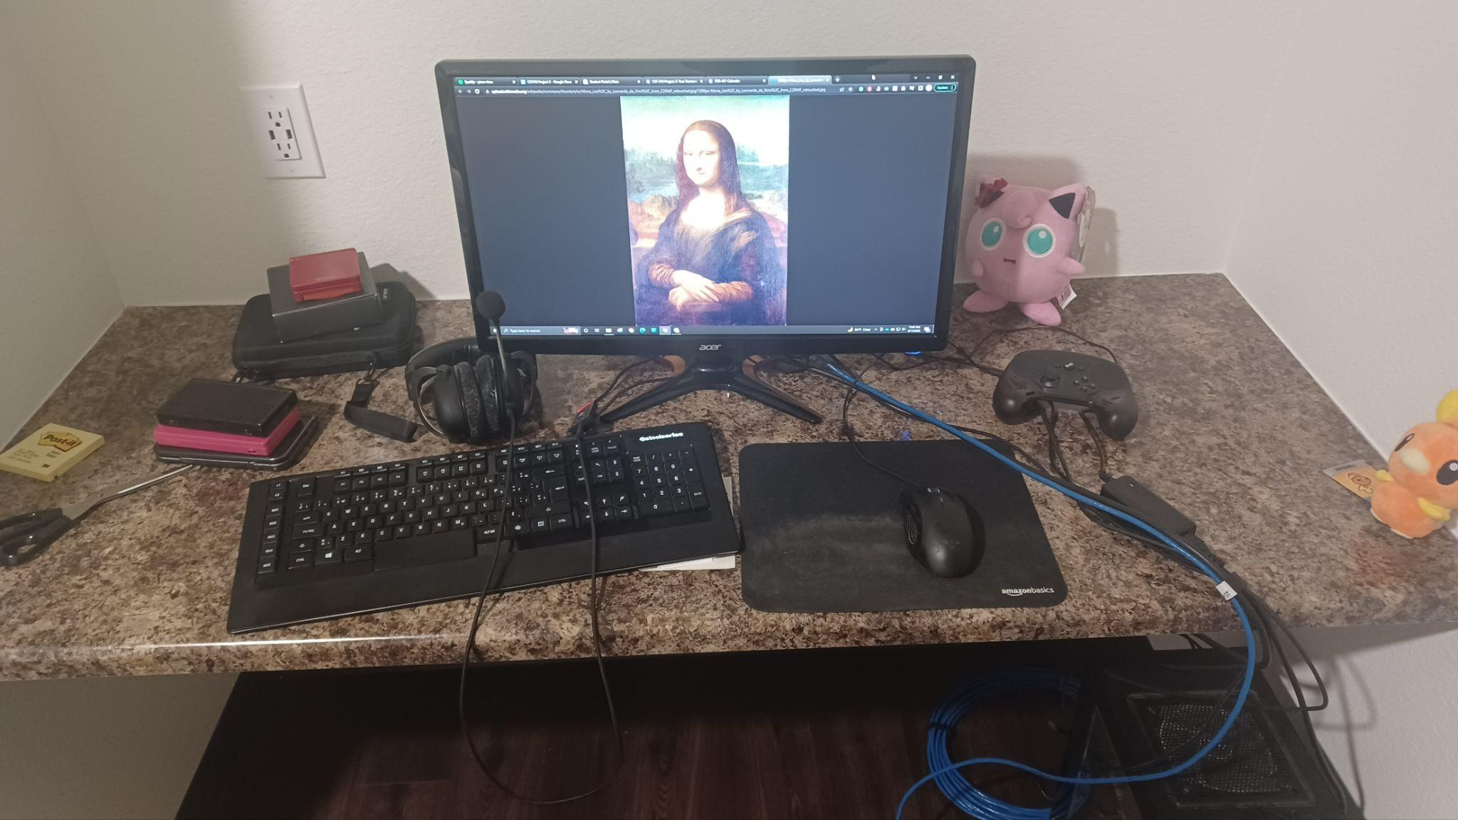

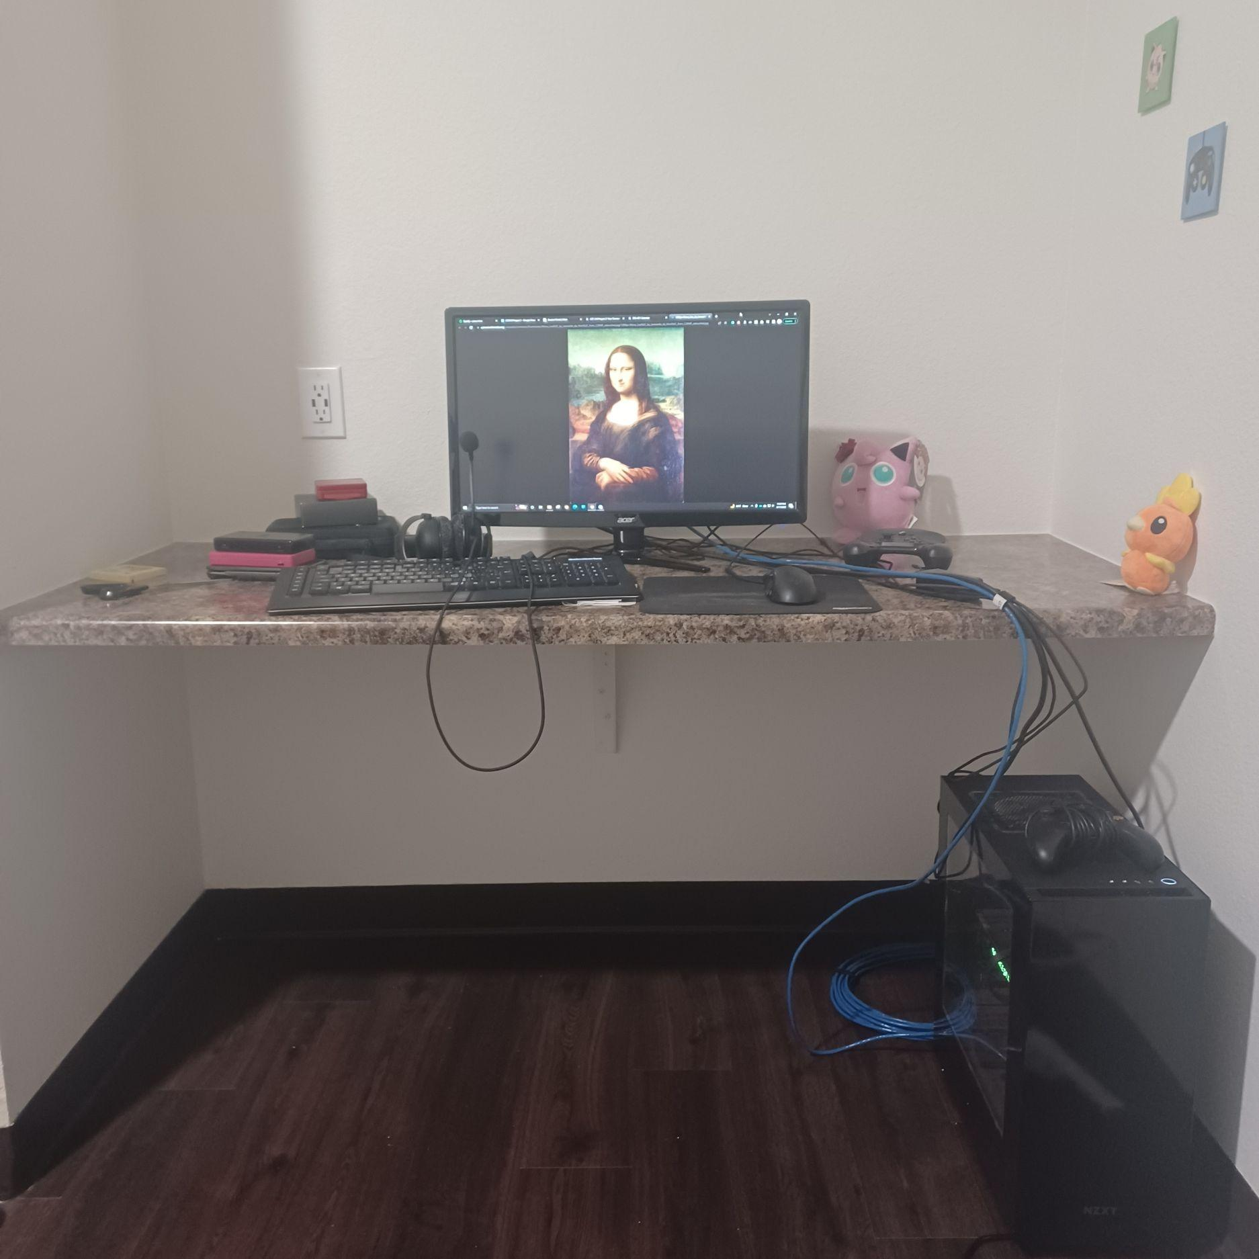

I thought this would be a good area because it has a good amount of items that aren’t a hard-to-make abstract shape. It’s mostly rectangles and circles except for the image on the computer monitor. There’s a bit of wires, but those could be represented by drawn lines.

Living area TV:

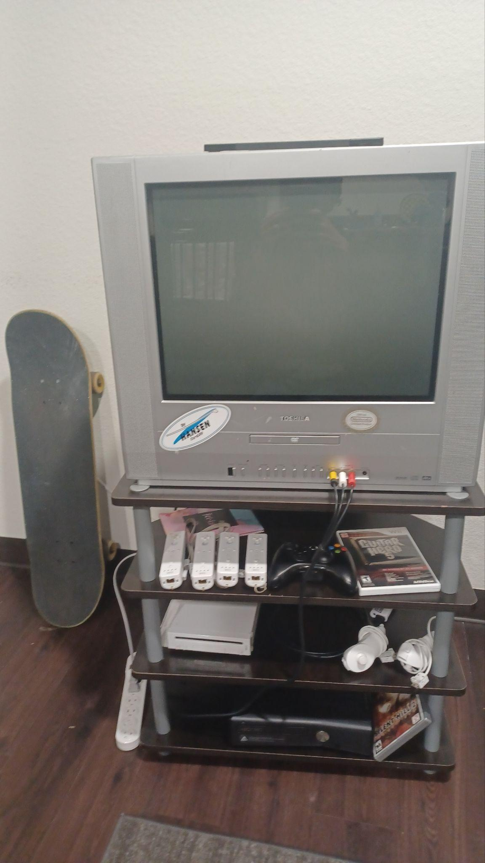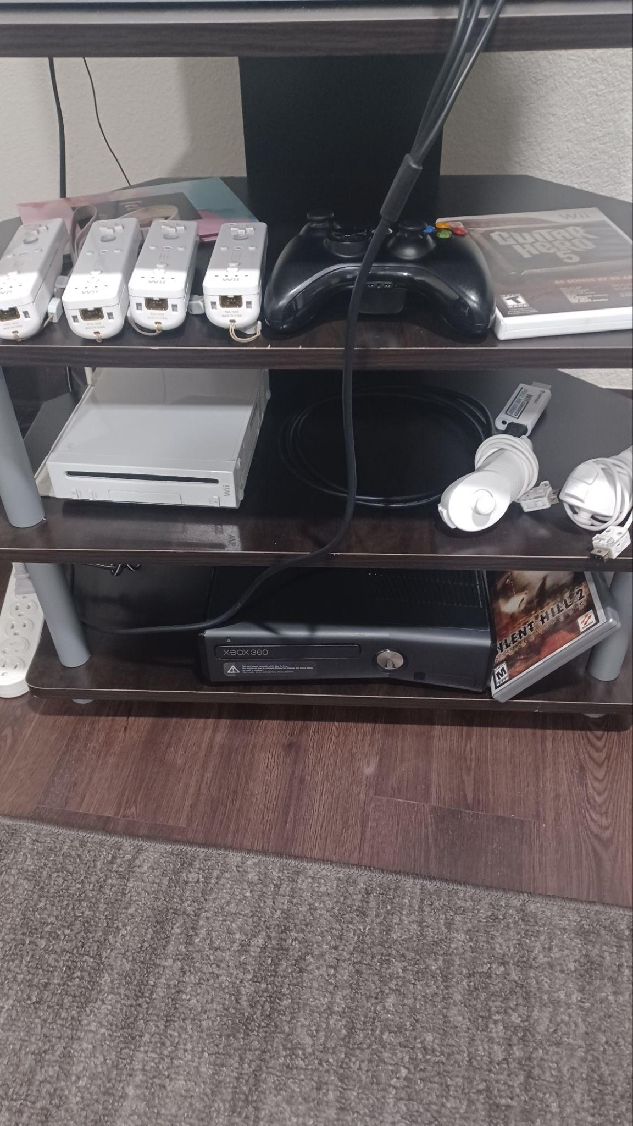

I chose this area because, again, there are many objects that aren’t too abstract of a shape. The tv itself has a lot of details to make, and same with to controllers with all of their buttons.

I (Ryan) took these next two pictures with my phone.

My kitchen sink:

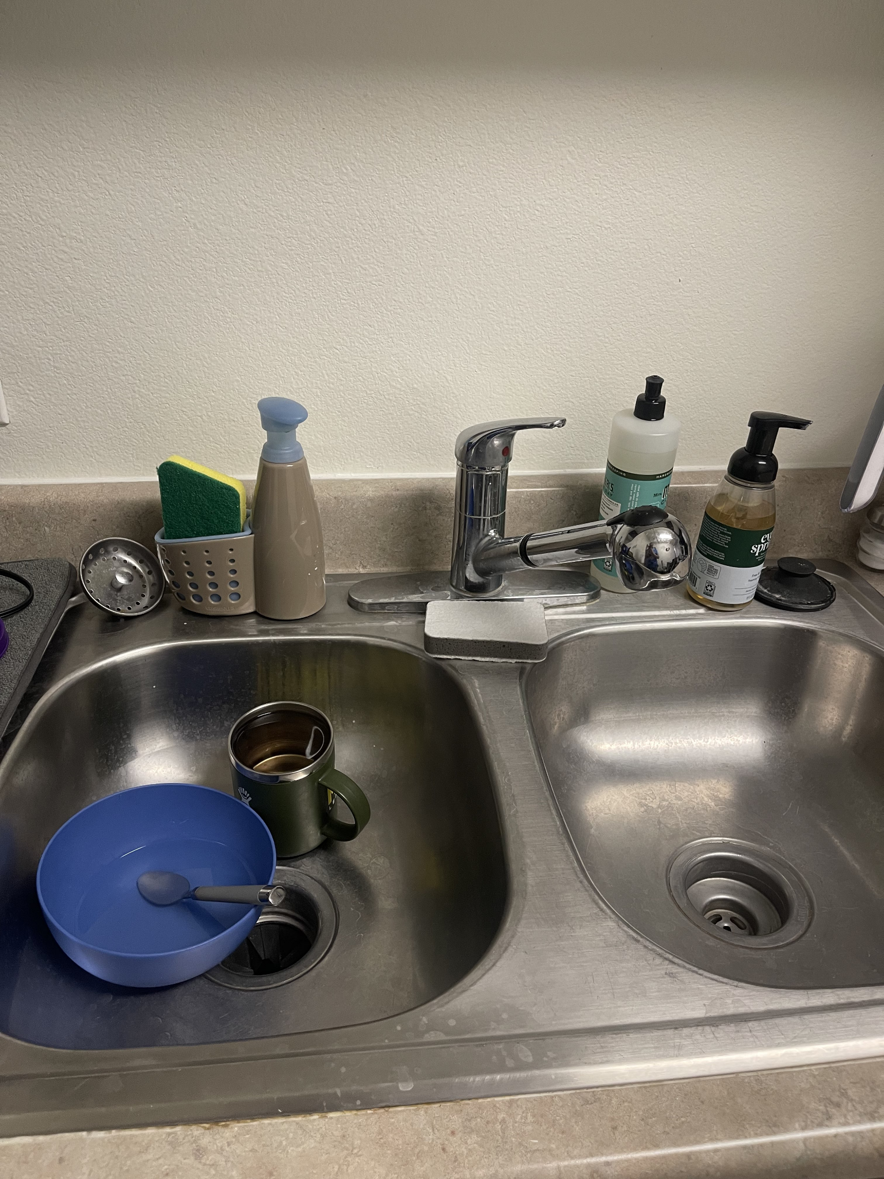

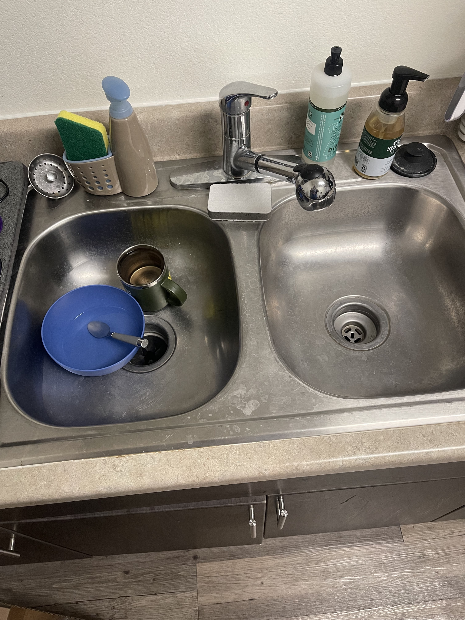

It's a good area to practice curves. The drain, bowl, spoons, and even the faucet itself have curves. Various techniques are required to recreate everything. There is no doubt that the faucet is the most complex abstract shape in this scene.